***Project Report***

***on***

***Network Management System of A Group of Company.***

***Submitted by***

1. Md. Rezaul Karim [161-15-6785]
2. Md. Pias Hossain [161-15-7659]
3. Salma Khatun [161-15-7362]
4. Md. Aslam Tauhid Reza [161-15-6913]

***Submitted To***

Ms. Fernaz Narin Nur

Assistant Professor

Department of CSE

Daffodil International University

Objective:

Network services can help our build a reliable, cost effective, and future-proof network to meet any need. So we can spend less time worrying about how to build your network and focus instead on the possibilities it will create for our organization.

A network is defined as interconnected collection of autonomous computers. Computer are said to be interconnected, if they able to exchange information. Connection is physically established through cables, lasers, microwaves, fiber optics and communication satellite.

In a network, the user must logon to the network, locate files and submit jobs. The network management has to be handled personally by the user. In a distributed system, all jobs are done automatically by the system without the user’s knowledge. Hence the distributed system is a special case of network system, one whose operating system has a high degree of transparency.

Resource sharing is the main objective of the computer network. The goal is to provide all the program, date and hardware is available to everyone on the network without regard to the physical location of the resource and the users.

The second objective is to provide the high Reliability. It is achieved by replicating the files on two or more machines, so in case of unavailability (due to fail of hardware) the other copies can be used.

Computer organization has helped organization in saving money. This is due to the fact that the small computer has much better price to the performance ratio comparison than the large computer like mainframe. Mainframe computer are approximately ten times faster that the microcomputers, but they cost thousands times more. As a result of this imbalance, organization has preferred to install interconnected microcomputer connected to the mainframe computer.

**Sub-netting:**

IP Sub-netting for 22 subnets.



Sub-netting are calculate by following formula:-

**No of Subnets = 2^s**

**No of host per subnet = 2^h – 2**

**Subnet size = 56 – sum of bit**

**Subnet mask are fixed for all network.**

**Implementation & Description:**

**A Group of Company Network Design.**

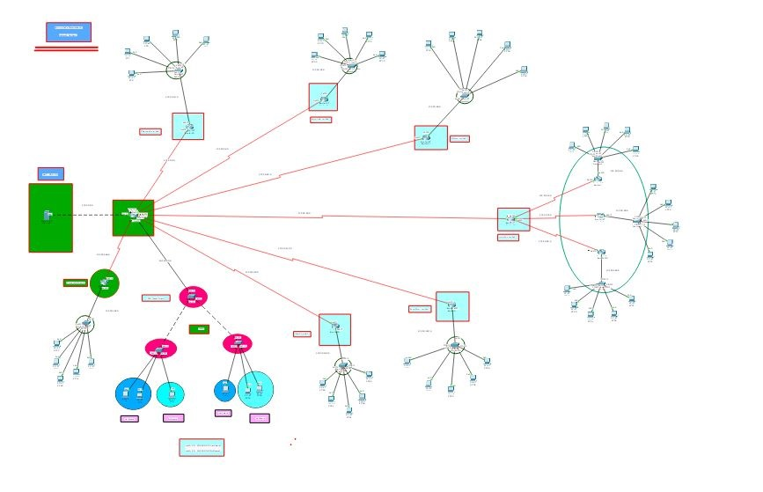

**Following image are only show the Main Server and NAT Routing Protocol System with core router:**

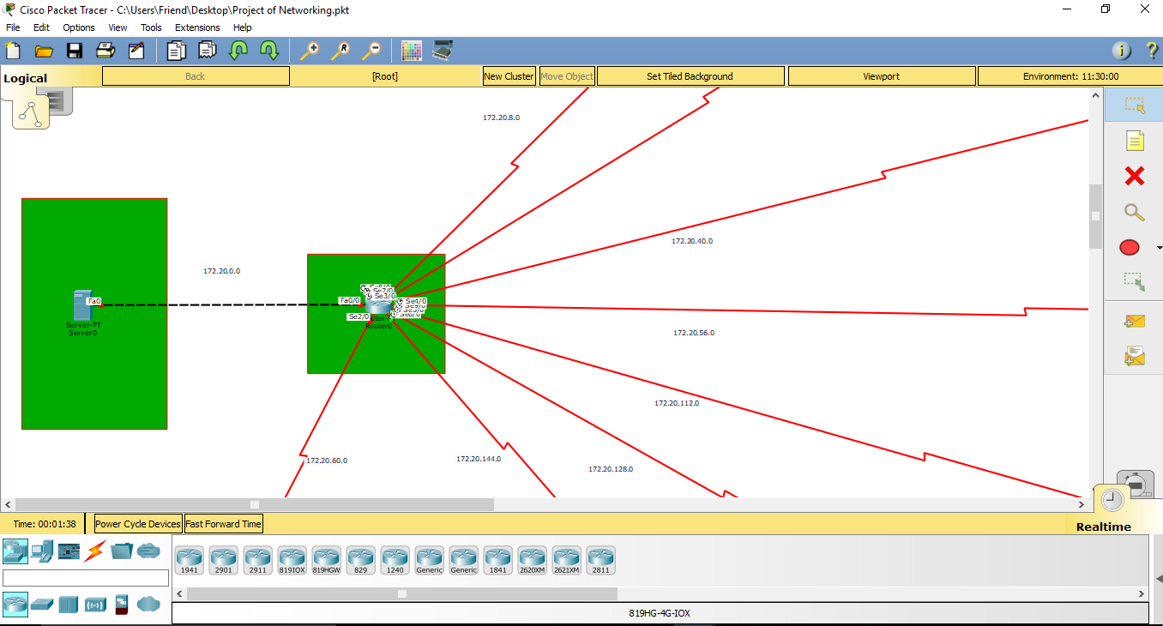

**Process of NAT configuration:**

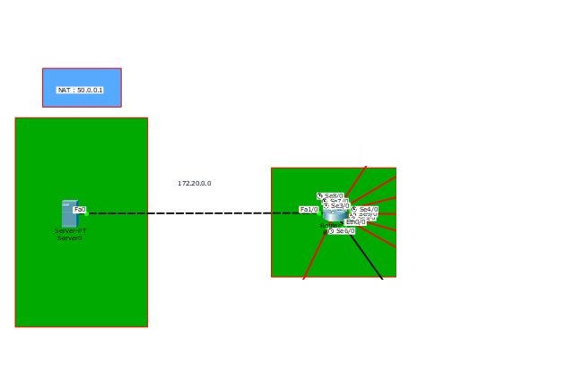

**Nat Configuration:**

**Router**

R1(config)# ip nat inside source static 172.20.0.2 50.0.0.1

R1(config)# int fa0/0

R1(config-int)# ip nat inside

R1(config)#exit

R1(config-int)# int se0/0

R1(config-int)# ip nat outside

R1(config)#exit

**Show Nat Table**

R1(config)# show ip nat tr

**Chemical Limited Network Topology:**

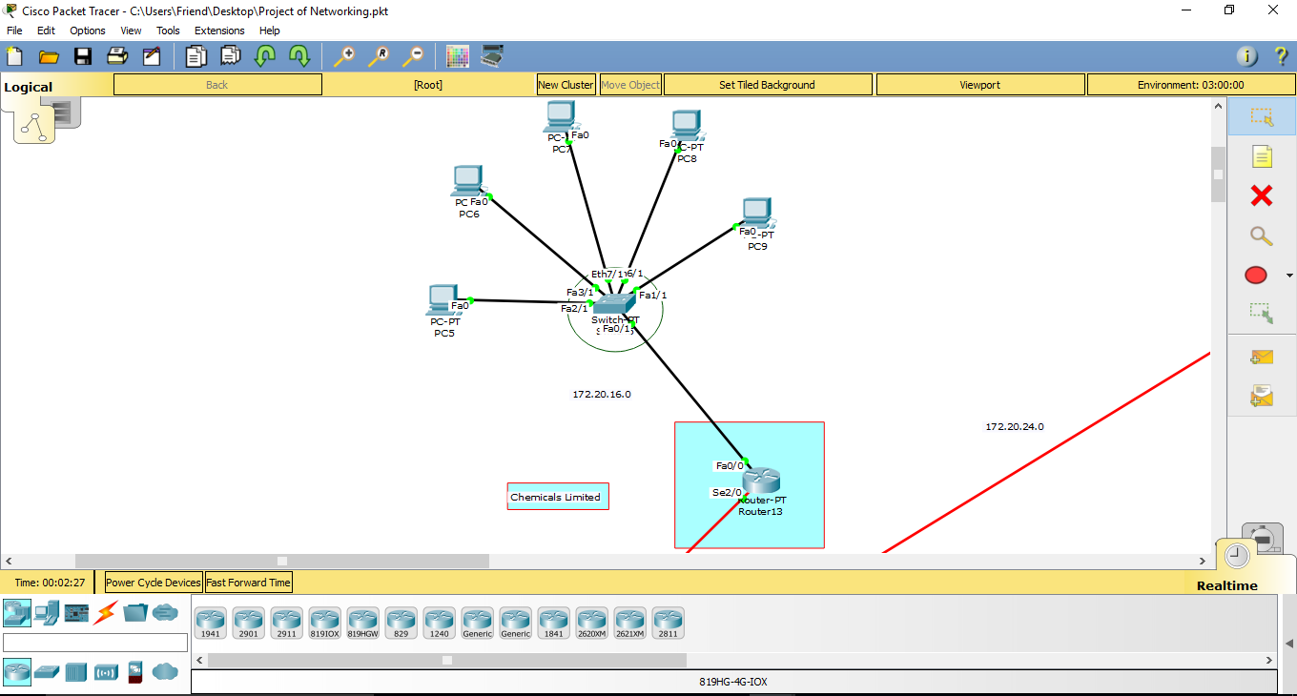

**Agro Link Limited & Motors Limited Network Topology:**

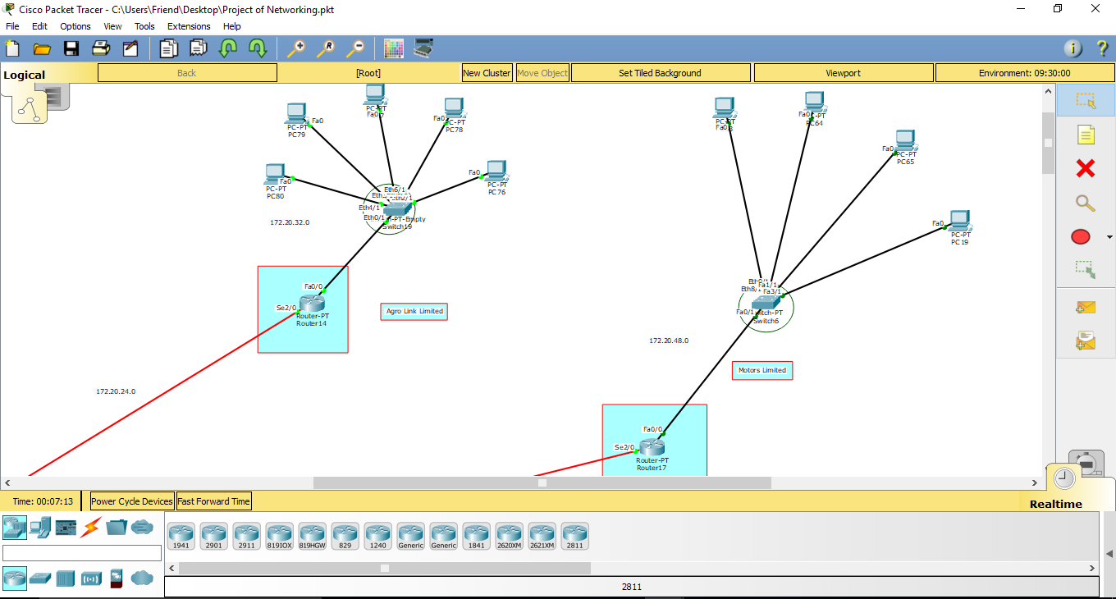

**Logistics Limited Topology:**

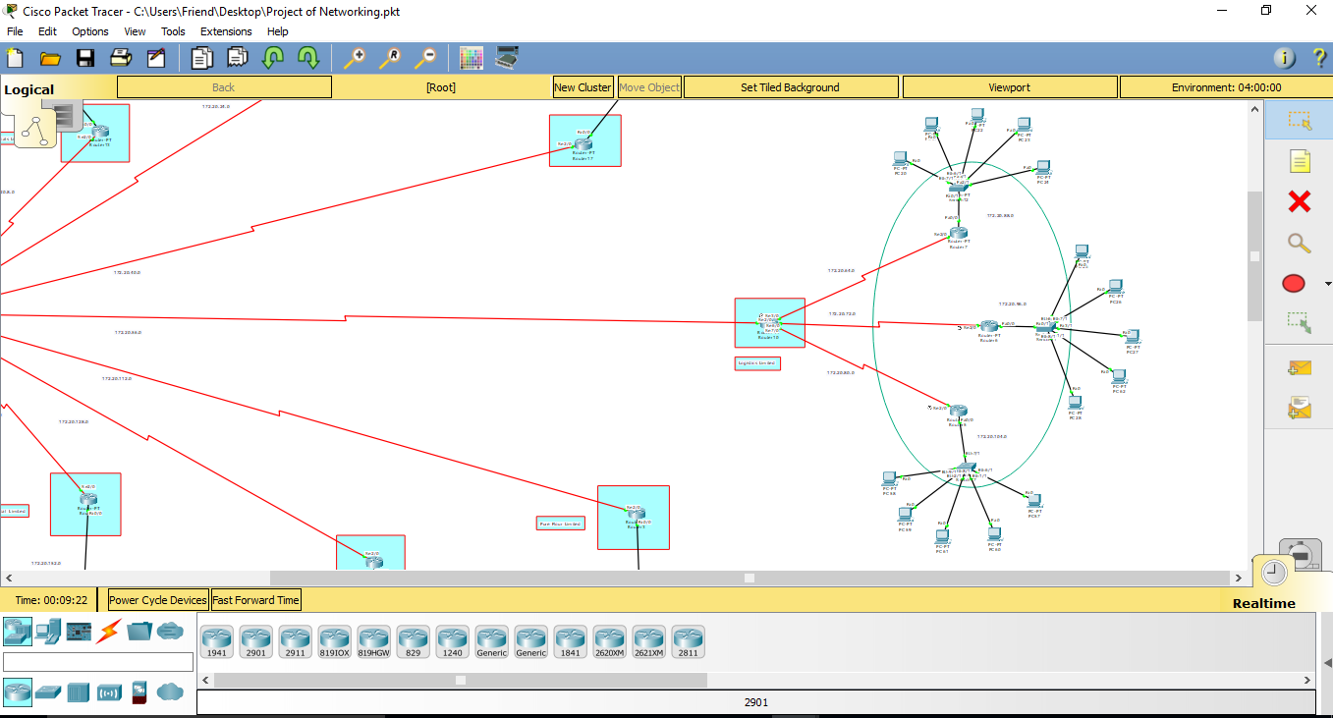

**Food Limited & Pure Flour Limited Network Topolgy**

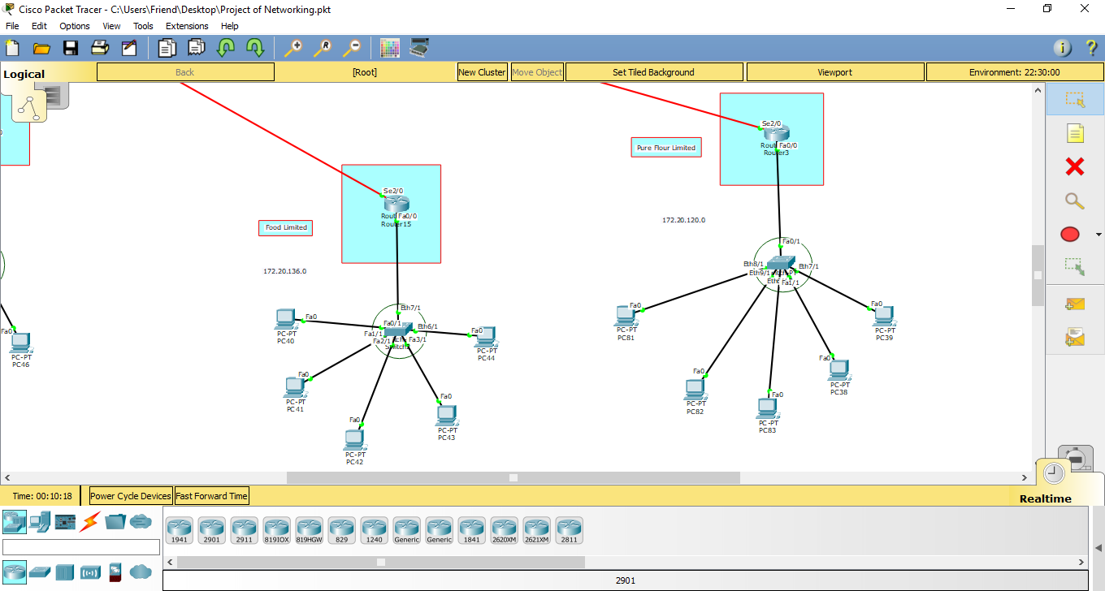

**Corporate Branch & Pharmaceutical Limited Network Topology:**

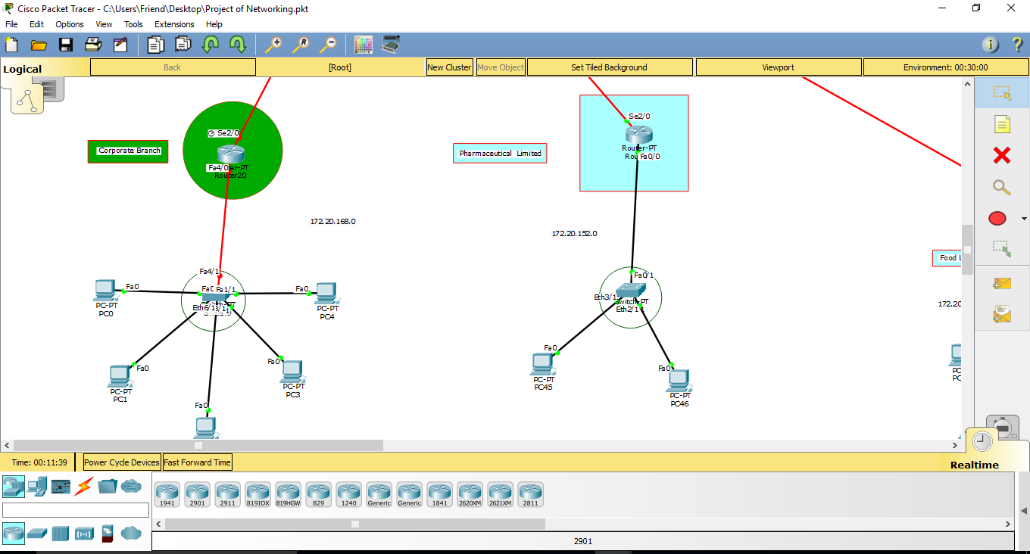

**Virtual LAN:**

**Following image are VLAN configure**

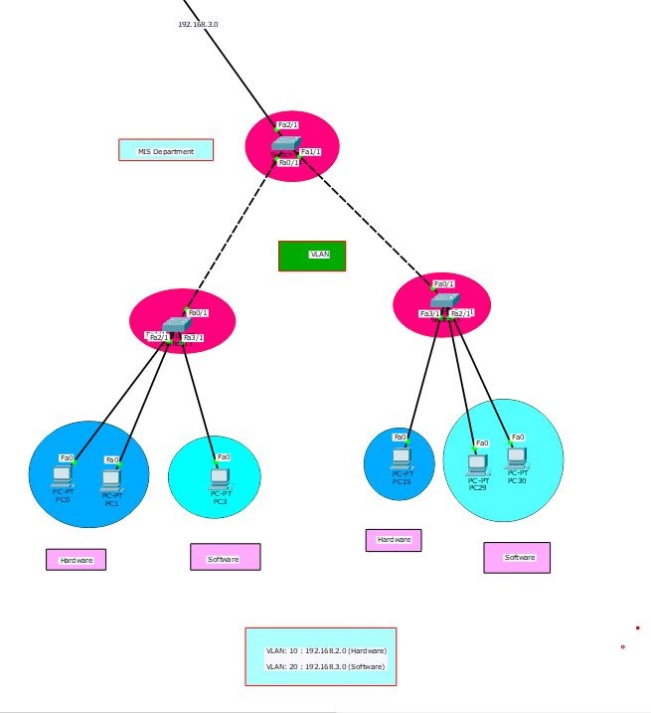

**Process of VLAN configuration:**

**Switch**

Switch>en

Switch# conf

Switch(config)# vlan 10

Switch(config-vlan)# name cse

Switch(config-vlan)# exit

Switch(config)# vlan 20

Switch(config-vlan)# name eee

Switch(config-vlan)# exit

**Trunk**

Switch(config)# int fa0/5

Switch(config)# Switch port mode trunk

Switch(config)# exit

Switch(config)# interface range fa0/1-4

Switch(config)# Switchport mode access

Switch(config)# exit

**Show VLAN Table**

Switch# show vlan brief